CSE212 Web Programming , Fall Semester 24/25

Assignment #1: Websites conceptual Design and mock-up

222100071 Ahmed Khaled Mohamed

**2.3.1. Part 1: research**

1) Web 2.0, often called the "Social Web," introduced a shift from static content to dynamic user-generated content. This phase focuses on participatory culture, where social networking, blogs, and wikis enable collaboration and sharing. The rise of social media platforms empowered user interaction, making Web 2.0 the foundation for user-driven content.

Web 3.0, also known as the "Semantic Web," adds layers of meaning to data, allowing machines to understand context. Key technologies in Web 3.0 include artificial intelligence (AI) and machine learning, which enable more personalized, meaningful interactions by analyzing and understanding user intent.

Web 4.0, sometimes referred to as the "Intelligent Web" or "Symbiotic Web," aims to create seamless interaction between humans and machines. In Web 4.0, AI and the Internet of Things (IoT) work together, adapting autonomously to users’ needs and creating highly intelligent, personalized experiences

2) Social Networking,User-Generated Content,APIs and Mashups.

These features helped create a more social, interactive, and networked internet that leverages the collective power of its users.

3) Semantic Web Technologies, AI and Machine Learning, Interoperability and Decentralization.

Web 3.0 gives data meaning and enhances connections by making information more accessible and understandable.

4) IoT Integration, Advanced AI, Context Awareness

These features create a future where the web acts as an extension of human intelligence, responding intelligently and autonomously to user needs

5) Collective intelligence:harnesses the power of communities to gather insights, creating a knowledge base that no single individual could produce.

Social networking and media platforms amplify this by allowing users to connect, share, and collaborate in real-time.

Social bookmarking organizes and categorizes knowledge, enhancing information discovery and contributing to an interconnected online community. These elements drive innovation and expand knowledge by leveraging user participation and collective expertise.

6) These technologies enable businesses to reach and engage customers in more dynamic and personalized ways:web2,web3,web4.

7)In my opinion , In web 3 I would could use it on independent applications and sites like:Lisk enables me to build decentralized applications using JavaScript

In web 4 it aims to the interaction between humans and machines in symbiosis

That it will be a huge development that will effects my career in a positive way.

**Refrences:**

[Author], "Web 4.0 Explained Brief," *LinkedIn*, Available: <https://www.linkedin.com/pulse/web-40-explained-brief-agiledistrict#:~:text=Web%204.0%20applications%20are%20designed,%2C%20and%20video%2Dsharing%20sites>. [Accessed: Nov. 4, 2024], pp. 1–2.

[Author], "Web 2.0," *Investopedia*, Available: <https://www.investopedia.com/terms/w/web-20.asp>. [Accessed: Nov. 4, 2024], p. 1.

[Author], "What is a Web3 App," *Lisk*, Available: <https://lisk.com/learn/undefined/what-is-a-web3-app>. [Accessed: Nov. 4, 2024], pp. 1–3

**Figma Website Link:**

**Prototype:** [**https://www.figma.com/proto/06x2ikh5tGAHalCj6PtAYe/Untitled?node-id=298-646&t=UObI3IzfETK0jMrT-1**](https://www.figma.com/proto/06x2ikh5tGAHalCj6PtAYe/Untitled?node-id=298-646&t=UObI3IzfETK0jMrT-1)

**Design** [**https://www.figma.com/design/06x2ikh5tGAHalCj6PtAYe/Untitled?node-id=298-646&t=UObI3IzfETK0jMrT-1**](https://www.figma.com/design/06x2ikh5tGAHalCj6PtAYe/Untitled?node-id=298-646&t=UObI3IzfETK0jMrT-1)

**2.3.3. Part 2: website design**

[A]

1) I used clean patterns to ensure each design comes out as cohesive and harmonious.

2) Use a pattern where shapes and motifs will flow fluidly into one another, with only minimum detailing to allow the viewer intuitively "fill in" gaps.

3) I symmetrically designed the graphics in such a way that they are balanced; hence, visually pleasing and satisfying to behold.

4) Employ contrasting colors or texture in my work to enable certain design elements to stand out from the background.

5) Applied similar colors or stitch patterns across related areas of your design for unity.

6) If certain areas are framed by a border or edge, this will be a way to visually group elements together, which is particularly helpful in complex or multicolor designs.

7) Stitches or motifs that are closer together will suggest a relationship and can build up the shape or design with them.

8) Continuous lines or stitches assist the viewer's eye to make the movement across the design naturally and with ease. This will emphasize flow.

9) Common Fate: Synchrony. Repeating patterns that "move" in the same direction, such as waves or chevrons, create a sense of unity and movement.

10) Parallelism: Using parallel stitch patterns creates visual continuity, lending to more organization and coherence.

11) Use the same colors, shapes, or textures throughout the design in order to make it cohesive; this can be applied to anything from blankets to a sweater.

12) Utilize widely recognized icons and navigation elements such as the shopping cart or search box to make the site more usable for users who have used other e-commerce sites.

[B]

1)1440,2513

2)

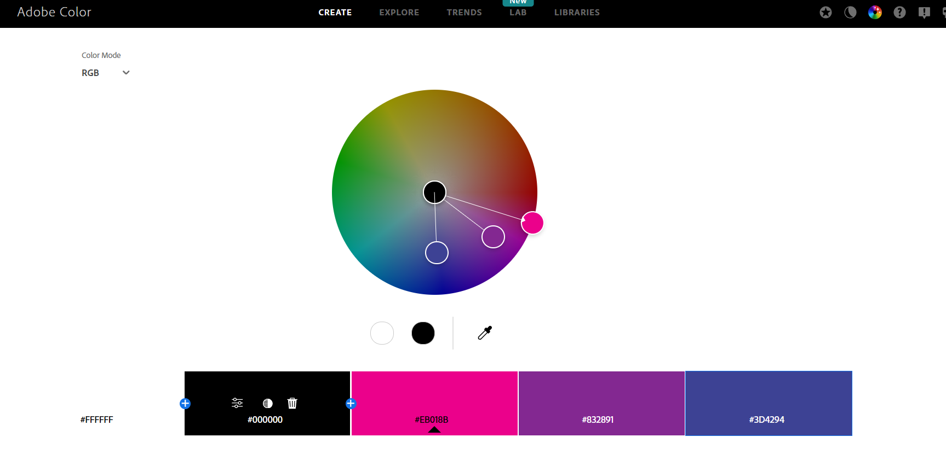

3)

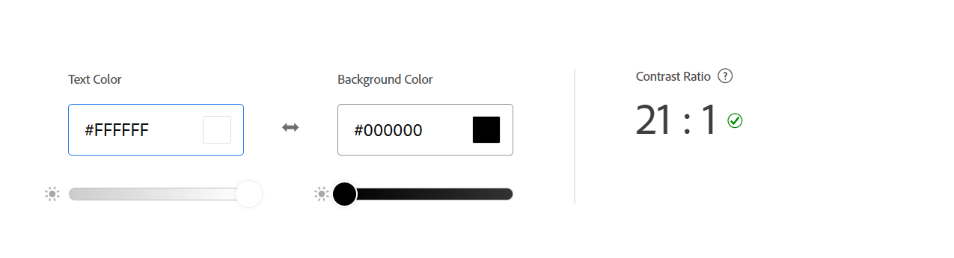

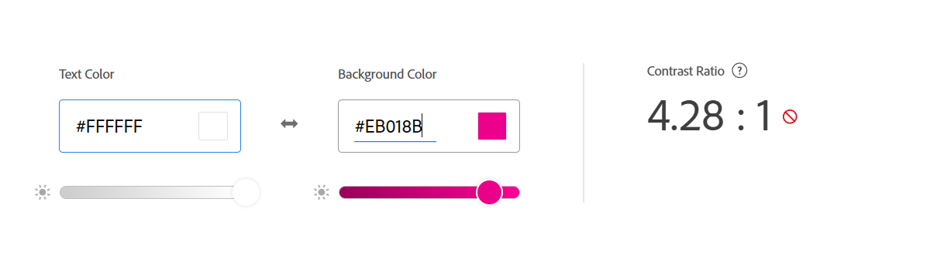

HTML, since that forms the backbone of any website; CSS is used for controlling the website formatting and layout; and JavaScript can be used to provide interactive elements on the website.

5) Shopify, Wix, and Squarespace are ideal, fully featured with easy setup, customizable themes, and in-built e-commerce functions. More advanced options involve WordPress with WooCommerce and Magento-their powers can be better utilized if a person has prior experience in using them. With any of these content management systems, you will be able to showcase your products, manage inventory, and even process payments, which makes it easy to launch and grow an online store.

6. PHP to develop Web pages, web applications; Laravel-to provide an inbuilt user interface, flexibility, and creativity.

7) Benchmark is going to be used for the measurement of website performance.

8)

<!DOCTYPE html>

<html lang="en">

<head>

    <meta charset="UTF-8">

    <meta name="viewport" content="width=device-width, initial-scale=1.0">

    <title>jcrochet</title>

    <link rel="stylesheet" href="styles.css">

</head>

<body>

    <header>

        <h1>jcrochet</h1>

        <nav>

            <ul>

                <li><a href="home.html">Home</a></li>

                <li><a href="about.html">About us</a></li>

                <li><a href="Categ.html">categories</a></li>

                <li><a href="contact.html">Contact us</a></li>

                <li><a href="FAQS.html">FAQS</a></li>

                <li><a href="Cart.html">cart</a></li>

                <li><a href="Whishlist.html">Whishlist</a></li>

            </ul>

        </nav>

    </header>

    <main>

        <section>

            <h2>Welcome to jcrochet</h2>

            <p>Welcome to jcrochet! We specialize in beautifully

                handcrafted leather and wool bags that merge timeless design with sustainable materials.

                Each piece is skillfully crafted by artisans using ethically sourced materials, blending style, function,

                and craftsmanship. Discover bags that tell a story and are made to accompany you on every journey.</p>

        </section>

        <article>

            <h2>Latest News</h2>

            <p>The latest in handmade leather and wool bags includes a focus on sustainability and personalization.

                Many brands now offer eco-friendly materials like vegetable-tanned leather and wool sourced responsibly,

                creating unique bags that age beautifully. Customization options, such as monograms or adjustable straps, a

                re also on the rise, giving customers a more personal connection to their bags and supporting the desire for unique,

                artisan-crafted items

            </p>

        </article>

    </main>

</body>

</html>

**2.3.2. Part 2: website planning**

It is to offer an online site where friends share, create, and sell hand-stitched leather and wool bags. This should offer growth support to the company by using an online platform that is reliable for sales, offering customers who appreciate good handmade bags and a brand built on friendship.  
2. Offer Pick-Up Options: If it is a locally-based clientele, the website can include the "Pick-Up In-Store" option where customers can place their order online and pick it up from a store nearby. This will be so convenient and sometimes faster to get access to products while saving on shipping.  
Announcement of Events and Promotions: The website can also announce special in-store events, promotions, or seasonal sales to create some buzz and community around the brand.  
We also aim at the end of the year to be able to produce products for men and boys.  
3) Target Group: Ladies/ Girls between 12 – 30 years old.  
4) Opportunities: The website will allow jcrochet to expand beyond physical stores across different states and countries where people appreciate handcrafted items and sustainability. In building an online store, the brand will be in a position to engage with customers who may have no access to a physical store.  
Problems: It might be cumbersome for customers outside of the store locations to purchase jcrochet products. The website addresses this by offering an avenue for online shopping, which increases its reach to people who may like the brand.  
Addressed issue: Customer service can be offered through the website by including features such as a chat box, frequently asked questions, and forms that can be filled out for inquiries to be addressed and cut time as well as avoid frustrations that may be associated with seeking support.  
5) Product listings and descriptions, About Us page, photo gallery and lookbook, contact information and customer support.  
6) To assist users in completing their tasks on the website, explicit product listings each product page will contain high-quality images, complete descriptions, price information, and customer reviews.

7) The website will feature a clean, user-friendly layout with an intuitive menu. Categories will be clearly labeled, To assist users with inquiries or issues, the website will include a dedicated support section with:

* FAQs: Addressing common questions about products, shipping, and returns.
* Contact Form: Allowing users to reach out for specific inquiries or support, with prompt responses expected.

8) Strategically placed buttons and links, such as “Shop Now,” “View Collection,” or “Learn More,” will guide users towards key actions throughout the site. These calls to action will be visually distinct and clearly labeled, encouraging users to engage with the content and make purchases.

9) The results of the jcrochet website's functions—such as product purchases, customer inquiries, and feedback—will be received in several ways:

* Order Confirmation Emails: Customers will receive immediate confirmation emails upon successful purchase, detailing their order, shipping information, and estimated delivery times.
* Feedback and Reviews: Customer reviews and feedback will be collected through forms on product pages and may be sent directly via email.
* Analytics Data: The website will utilize analytics tools (like Google Analytics) to gather data on user behavior, including page views, conversion rates, and bounce rates, providing insights into how well the site functions.

10) Once the results are received:

* Order Processing: The team will process orders by preparing items for shipment, updating inventory, and ensuring timely delivery.
* Customer Feedback Analysis: Reviews and feedback will be reviewed to identify trends, improve product offerings, and enhance the customer experience.
* Data Analysis: Analytics data will be analyzed to inform marketing strategies, website optimizations, and product development decisions.

11) The receiver, likely the jcrochet team, will handle results in the following ways:

* Timely Fulfillment: Orders will be fulfilled promptly to ensure customer satisfaction. Any issues with order processing will be addressed swiftly.
* Continuous Improvement: Based on customer feedback and analytics, the team will make iterative improvements to the website, product lines, and customer service practices.
* Customer Engagement: Positive feedback will be shared on social media or the website to build community trust, while negative feedback will be addressed proactively to resolve issues.

12) Post-Purchase Emails: Sending follow-up emails to customers after their purchase to thank them, request feedback, and encourage them to leave a review.

Customer Support: Providing additional support for any inquiries or issues that arise after the sale, ensuring customer satisfaction.

Periodic Surveys: Conducting surveys periodically to gauge customer satisfaction and gather insights for future improvements.

13) Here are two related sites that may serve as inspiration for the jcrochet project:

Etsy ([www.etsy.com](http://www.etsy.com)):

* + Reason for Choice: Etsy is a well-known platform for handmade and artisanal products. It showcases a wide variety of handcrafted items, providing insights into product presentation, customer engagement, and community building. The site offers an excellent model for how to effectively market and sell unique products online, especially within the handmade and sustainable niche.

Made Trade ([www.madetrade.com](http://www.madetrade.com)):

* + Reason for Choice: Made Trade is an online marketplace specializing in ethically sourced and sustainably made products. The site emphasizes its commitment to fair trade, sustainable practices, and artisan craftsmanship. Its focus on storytelling and transparency can provide valuable lessons for jcrochet in terms of brand positioning and connecting with socially conscious consumers.

These sites were chosen because they exemplify successful strategies for promoting handmade products and ethical sourcing, which aligns with jcrochet's mission and target audience. They can offer valuable insights into branding, customer engagement, and e-commerce best practices.

14)

a. The primary goal of the jcrochet website is to provide an engaging online platform for customers to discover, learn about, and purchase handcrafted bags made from leather and wool. The site aims to build brand awareness, promote sustainable fashion, and foster a community of customers who appreciate artisanal craftsmanship.

b.categories.about us,FAQS,contuct us,whishlist,support.

c. Homepage

* Contents: Engaging hero image showcasing featured products, a brief introduction to the brand, highlighted links to shop categories, and an overview of the brand’s commitment to sustainability. Includes navigation links, a call to action (e.g., “Shop Now”), and a footer with contact information and social media links.

Shop

* Contents: A gallery of products with images, names, prices, and quick views. Filters for sorting by category, price, or new arrivals. Users can click on products for detailed descriptions and options to add to the cart.

About Us

* Contents: A detailed narrative about the jcrochet brand, its mission, values, and the artisans behind the products. Includes pictures of artisans at work, the crafting process, and a commitment to sustainability.

Our Products

* Contents: A dedicated page for showcasing specific product categories (e.g., bags, accessories) with detailed descriptions, materials used, and care information. High-quality images and links to purchase items.

Customer Reviews

* Contents: A compilation of customer testimonials and ratings for various products. Users can submit their reviews via a form.

FAQs

* Contents: A list of frequently asked questions covering topics like shipping, returns, materials, and care instructions. This page aims to provide quick answers to common customer inquiries.

d. Forms will be used on the website in various ways:

* Newsletter Subscription Form: Users can enter their email addresses to subscribe to the newsletter, providing a means for the brand to communicate directly with interested customers.
* Customer Review Submission: A form will allow customers to submit reviews and ratings for products they have purchased, contributing to community feedback and enhancing the product pages.
* Contact Form: Users can submit inquiries or feedback through a contact form, which will facilitate direct communication with the jcrochet team.

e.

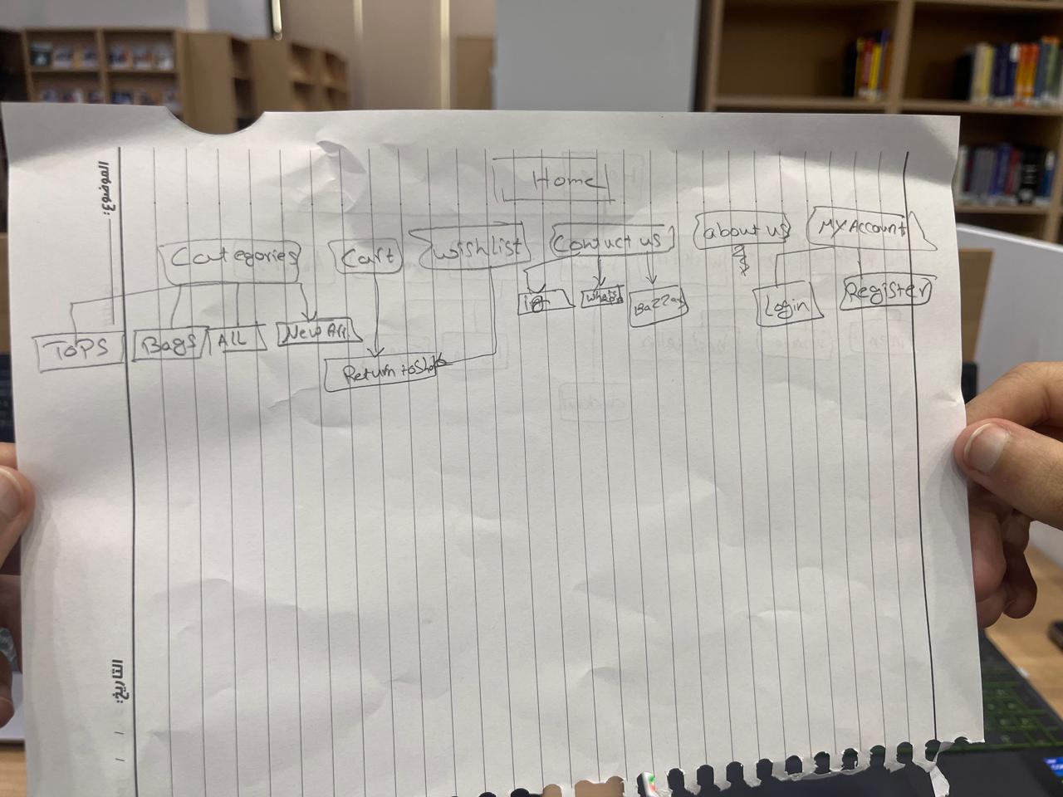

f.

